ĐỀ 15 | ĐỀ KIỂM TRA CUỐI HỌC KỲ II  NĂM HỌC 2025-2026  MÔN: TIẾNG ANH LỚP 5
PART I: LISTENING (10 minutes).
Task 1: Listen and number (1.0 pt)

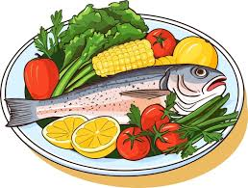 | 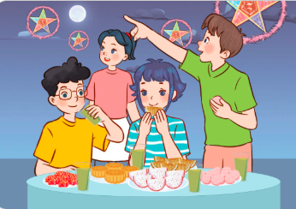 | 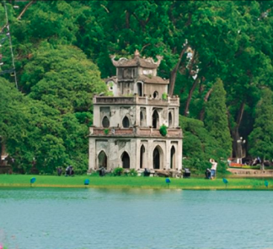 | 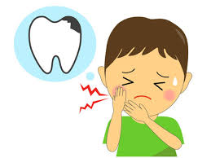 | 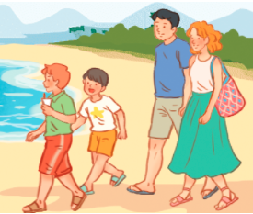
A. | B. | C. | D. | E.

Task 2: Listen and circle A, B or C (1.0 pt)
1. The main characters in the story are ____________.
A. the man and the fox B. the ant and the box C. the ant and the fox
2. Mai went to Phu Quoc with ____________.
A. her friends B. her family C. her sister
3. The boy will __________ on Tet holiday.
A. do shopping B. make spring rolls C. buy a branch of peach blossom
4. What season is it in Ha Noi?
A. spring B. winter C. summer
5. They go to National Park by __________.
A. taxi B. bus C. bicycle
Task 3: Multiple choice questions (2.0 pts)
A.* Odd one out
1. A.earache B.toothache C.sore eye D. symptom
* Which word has the different stress pattern .
2. | A.seashell | B.headache | C. souvenir | D.humid
B. Circle the correct answer A, B, C or D
3. How ……….is it from Can Tho to Vinh Long? It’s about 40 kilometres.
A. long B.far C. much D. about
4. How does your mother stay healthy? She ……….yoga every morning
A. makes B. plays C. does D. goes
5. What are you going to do this summer? I’m going to visit ….eco-farm.
A. a B. some C.any D.an
6. What did you do ……….Malaysia? I bought ……….souvenirs for my family. (M3)
A. at/ some B. in/some C. on/a D. in/ any
7. How can I get to Dam Sen Park? You can get there……..foot.
A. by B.with C.on D. in
8. What drink will you have………..the party? I will have ……………
A. at/ milk tea B. on/ apple juice C.at/ apples . D. in/ milk tea.
9. What is the matter? I…………..a sore throat.
A. have B. had C. has D. am
10. How did the bird sing? It ………………beautifully.
A. sing B.song C.sang D.sings
Task 4. Read the passage and tick (✓) True or False (1.0 pt)
My name is Sally. I do a lot of things to stay healthy. I eat fruit and vegetables every day. I do not eat junk food like chocolate, chips and ice cream. I drink juice instead of milk tea.Every day, I do morning exercise. I play sports, too. I play basketball with my friends three times a week. Sometimes I do aerobics or go to judo class. I am active and feel great every day.

 | True | False
- Sally eats fruit and vegetables every day.
- She doesn’t drink milk tea
- She occasionally does aerobics
- She plays basketball with her friends four times a week.
- She has a healthy lifestyle.
Task 5. Read the passage and answer the questions (1.0 pt)
Lan and her parents are (1)________to visit London this summer. First, they are going to visit Buckingham Palace. It is a beautiful place where the Kings (2)_______. After that, they are going to visit Big Ben. Big Ben is a very large (3)_______inside a tower. There is a clock on the tower. Then, they are going to see the London Eye. It is a big, tall wheel that moves around. It looks beautiful (4)______night. Finally, they are going to visit Tower Bridge. It is over the River Thames, one of the famous (5)_______ places in London.
1.A. coming B. going C. playing D.making
2.A. plays B. paints C. dies D. lives
3.A. bridge B. bell C. tower D. place
4.A. by B. at C. on D. in
5. A. historic B. history C.histories D. beautiful
Task 6. Fill in each blank with ONE suitable word. (1.0 pt)
  Example:  0.The notebooks are beside the school bag | 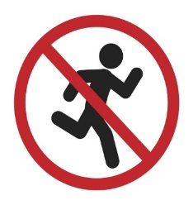  1. This sign means we mustn’t ______________.
  2. It will be_____________tomorrow. |   3. I want to visit____________.
  4. You can get there by________. | 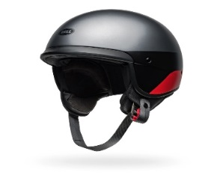  5. You should wear a _________ when you ride a motorbike.

Task 7. Reorder the words to make sentences. (1.0 pt)

1. I / with my brother/ yesterday./ collected the seashells/
..........................................................................................................................................................................................................................................................................................

2.What food / will you/ at the party?/ have //

We/ some burgers / will have/ sandwiches. /and

............................................................................................................................................

.............................................................................................................................................3. What/ with/ the/ matter/ you?/ is//

I/ a/ bad sorethroat./ have/

..........................................................................................................................................................................................................................................................................................

4. I/ visit/ to/ want/ Ngo Mon square/ friends./ with my

............................................................................................................................................. 5. can/ How/ get to Dam Sen /we/ water park? // can/ get/ there/ by taxi./ You

.............................................................................................................................................

............................................................................................................................................
______ The end ______
HƯỚNG DẪN CHẤM ĐỀ KT CUỐI KÌ II
Task 1: Listen and number (1 điểm = 0.2đ/câu đúng)
- B 2. C 3. A 4. D 5. E
Task 2: Listen and cirlce A, B or C (1 điểm = 0.2đ/câu đúng)
- C 2. B 3. B 4. B 5. A
Task 3: Multiple choice questions (2.0 pts)
1.D 2.C 3.B 4.C 5.D 6.B 7.C 8.A. 9.A 10.C
Task 4. Read the passage and tick (✓) True or False (1.0 pt)
1.T 2.T 3.T 4.F 5.T
Task 5. Read the passage and answer the questions (1.0 pt)
1.B 2.D 3.B 4.B 5.A

Task 6. Fill in each blank with ONE suitable word. (1.0 pt)
- walk 2. rainy 3. Hoi An Old Town 4. taxi. 5. helmet

Task 7. Reorder the words to make sentences. (1.0 pt)

1. I collected the seashells with my brother yesterday.

2.What food will have at the party?

We will have some burgers and sandwiches.

3. What is the matter with you?

I have a bad sorethroat.

4. I want to visit Ngo Mon square with my friends.

5. How can we get to Dam Sen water park? You can get there by taxi.

