ĐỀ 13 | ĐỀ KIỂM TRA CUỐI HỌC KỲ II  NĂM HỌC 2025-2026  MÔN: TIẾNG ANH LỚP 5

PART I: LISTENING
Task 1. Listen and number.

A.  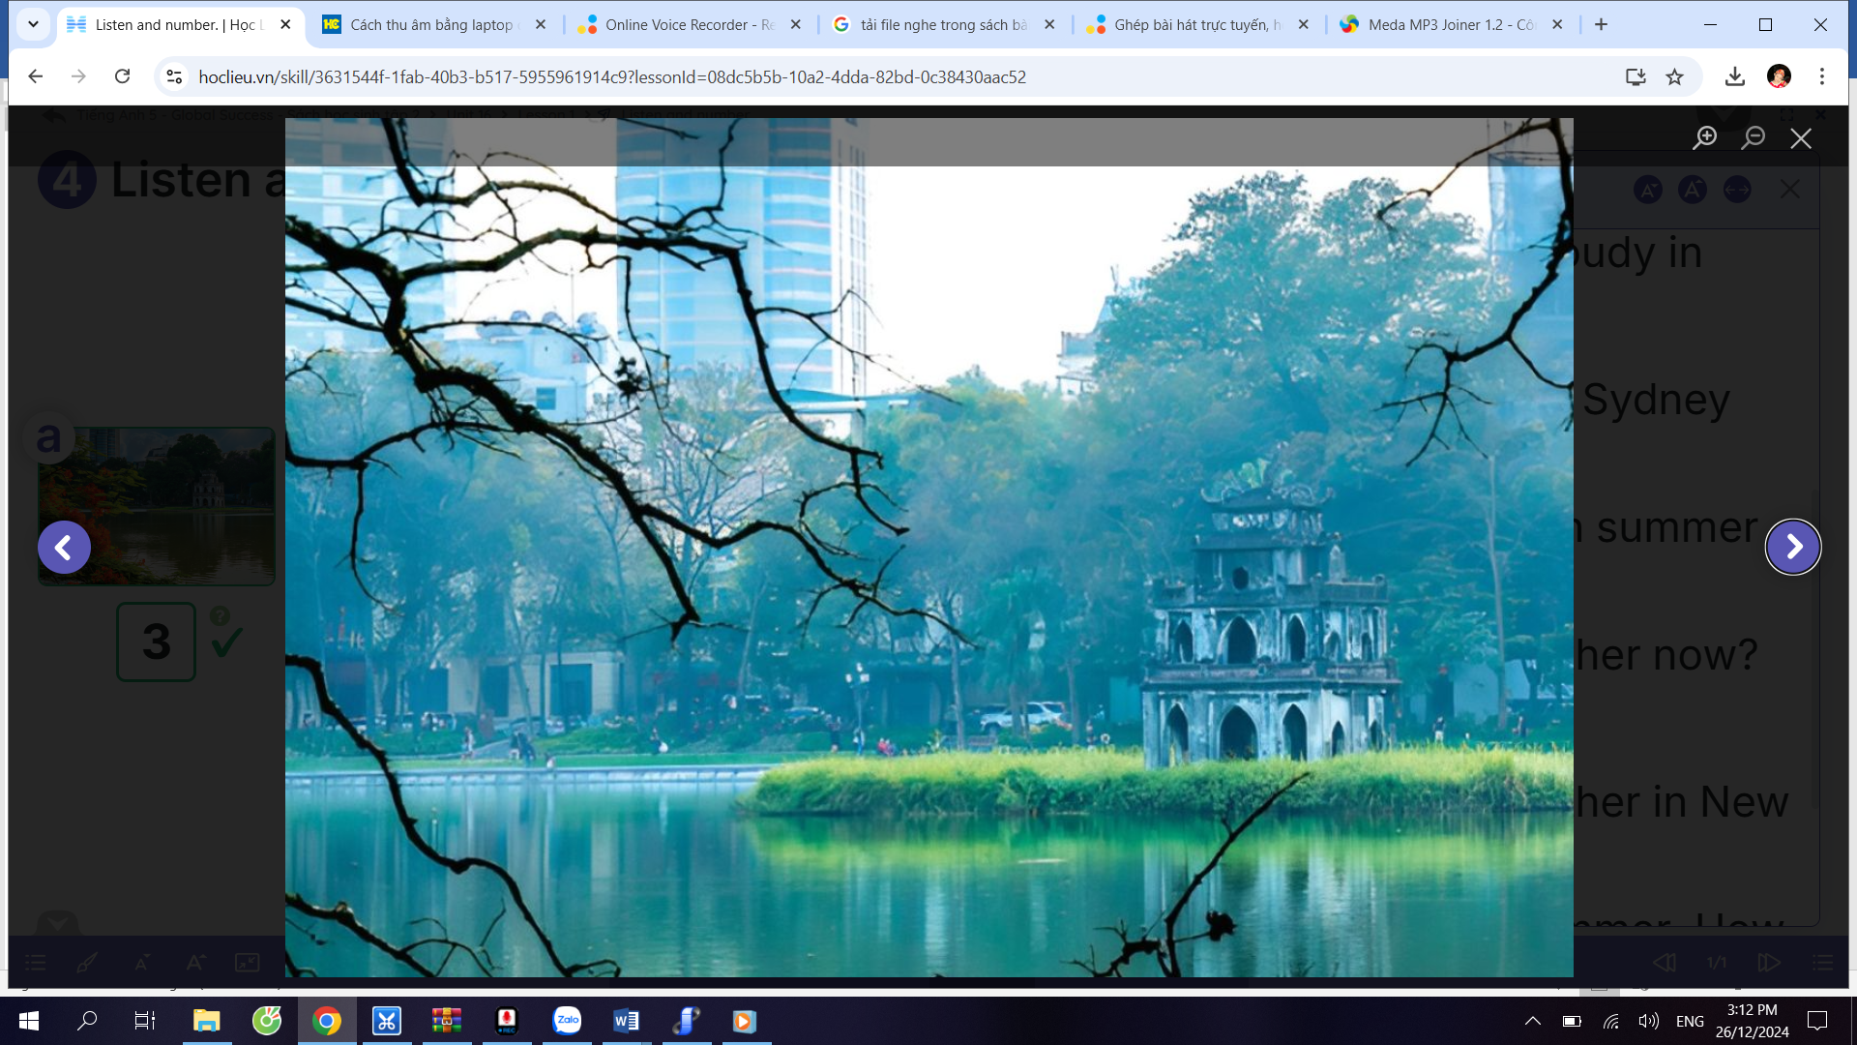 | B.  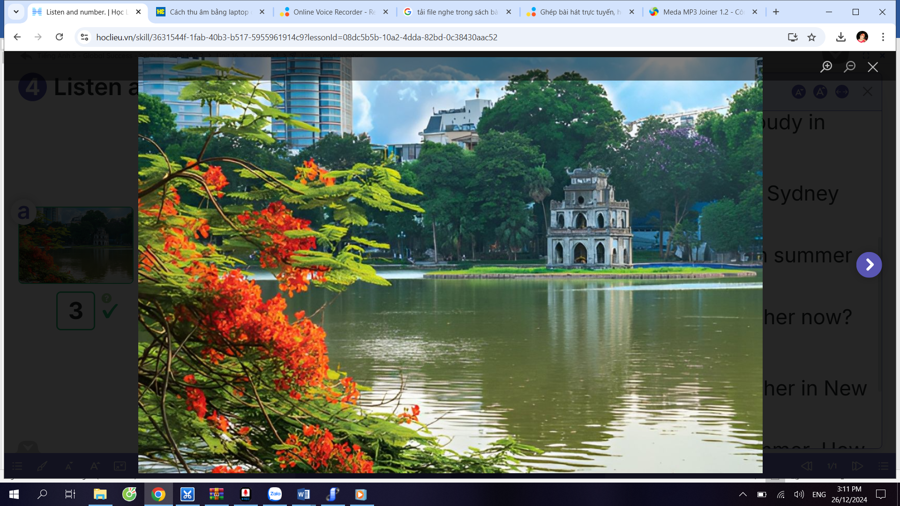
C.  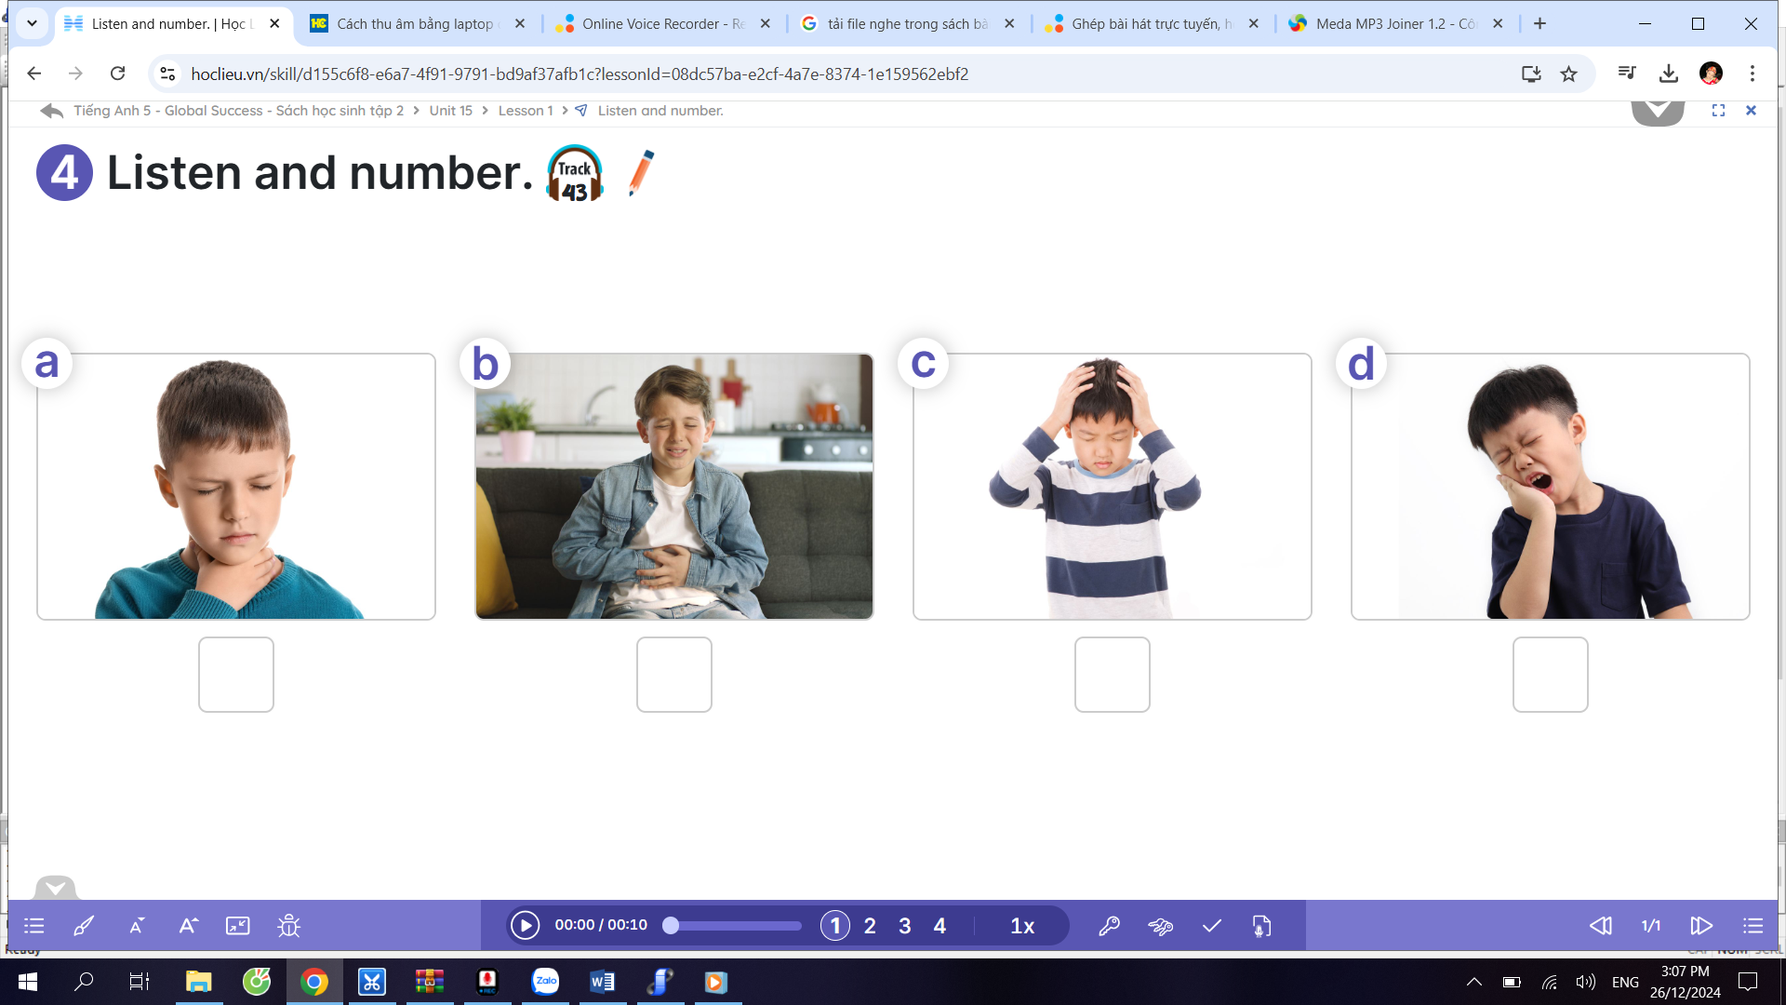 | D.  
E.
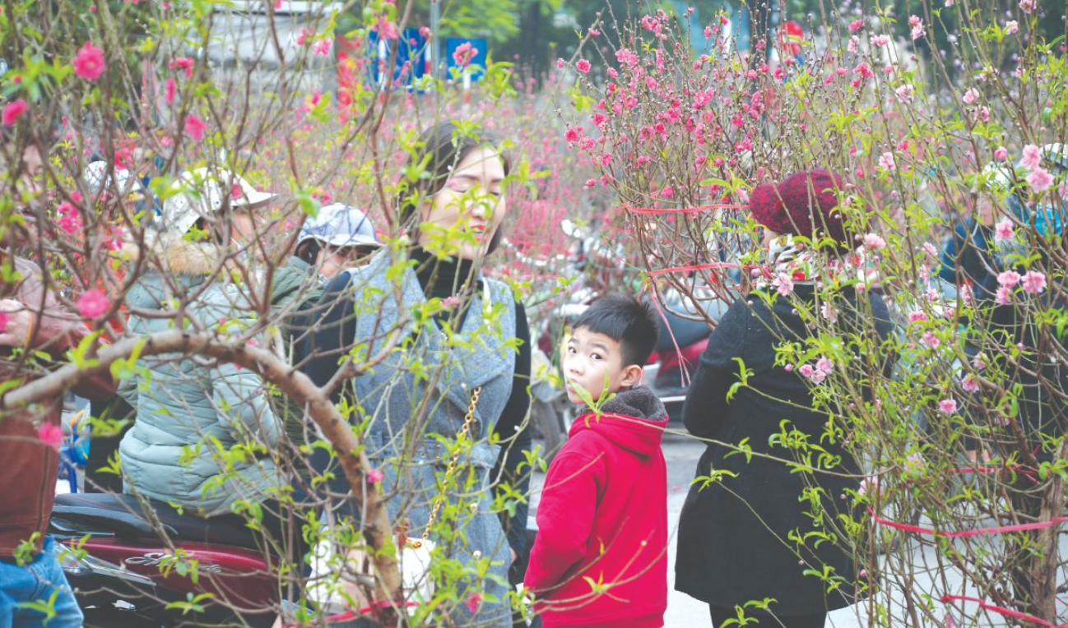

Task 2. Listen and circle A, B or C.
- Did you go to Phu Quoc last weekend?
- Yes, I did. I went there with my ________________ .
- friend B. family C. parents
- What did you do there? - We ________________ .
A. bought some souvernirs
B. saw some interesting places
C. took some photos
- Will you make ________________ for Tet?
A. cakes B. flowers C. spring rolls
- How often does she drink ________________ ?
- orange juice B. milk tea C. coffee
- I am going to visit ________________ .
- Phong Nha Cave in Da Nang
- Phong Nha Cave in Quang Binh
- Ancient town in Hoi An
PART II: VOCABULARY, PHONICS, GRAMMAR
Task 3. Circle the correct answer.
1. Odd one out (Tìm từ khác loại).
A. flu B. head C. ear ache D. sore throat
2. Choose the word that has different stress partern from the other words (Chọn từ có trọng âm khác so với các từ còn lại):
A. badminton B. countryside C. bakery D. October
3. Will you decorate the house for Tet? - _______ .
A. No, I will. B. No, I don’t. C. No, I won’t. D. No, I didn’t.
4. What did your family do in Nha Trang? - We ____ in the sea and ate seafood.
A. swim B. swam C. swimmed D. swimming
5. How does your sister _______ healthy? – She _______ yoga.
A. stays / does B. stay / does C. stay / do D. stays / do
6. How did Snow white cook? - She cooked very ______.
A. good B. beautiful C. well D. goodly
7. Where do you want ______? - Ngo Mon Square.
A. visit B. visited C. visiting D. to visit
8. How can I get to Hoan Kiem Lake? - You can get there ________ bus.
A. by B. in C. at D. of
9. A: I don’t feel well. I have a fever.
B: You should ______ some medicine.
A. taking B. takes C. take D. to take
10. What do you usually wear in ______? - I wear a ______.
A. spring / trousers B. summer / jeans
C. autumn / thick scarf D. winter / jumper
PART III: READING AND WRITING
Task 4. Read and tick (√) True or False.
My sister, Mary, is four years old. She likes eating candies in the evening. She does not like brushing her teeth before going to bed. Yesterday, she could not sleep because she had terrible pain in her tooth. Mom took her to the hospital in the morning to see the dentist. The dentist said that Mary should brush her teeth after meals. She should not eat sweet things in the evening.
 | T | F
1. Mary likes eating sweet things in the evening.
2. She had a toothache yesterday.
3. She went to the hospital with her father.
4. The dentist said that she should brush her teeth every morning.
5. Mary shouldn't eat sweet things in the evening.

Task 5.Read the passage and choose the correct answer A, B, C or D.
Hoan Kiem Lake is like a calm spot (1) _____________ the middle of busy Hanoi. It's (2)______________ by green trees and old buildings. In the middle of the lake (3) __________ a tall tower shaped like a turtle. This tower is special because it shows how strong Hanoi is. To visit Hoan Kiem Lake, people can come to Hanoi (4) _________ plane and then take a taxi or walk around. It's (5) _____________ peaceful place with lots of history and beauty, perfect for relaxing or enjoying the view.
1. A. in B. at C. on D. of
2. A. surround B. surrounded C. surrounding D. surrounds
3. A. there're B. they're C. there's D. its
4. A. by B. and C. of D. for
5. A. an B. the C. X D. a

Task 6. Fill in the each blank with ONE suitable word.
1. My father and I will ____________ the shopping for Tet. | 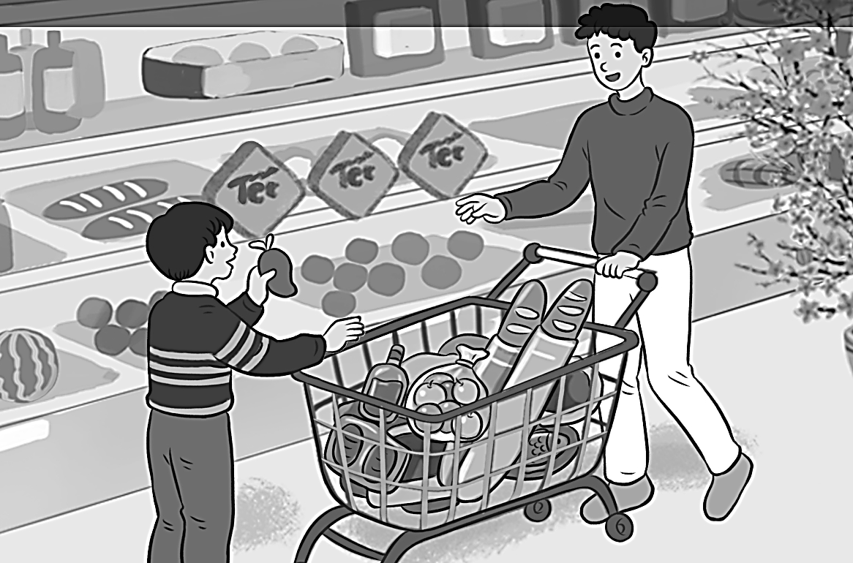
2. To stay healthy, she does morning ____________ daily. | 
3. What’s the matter with you?  I have a ____________ . | 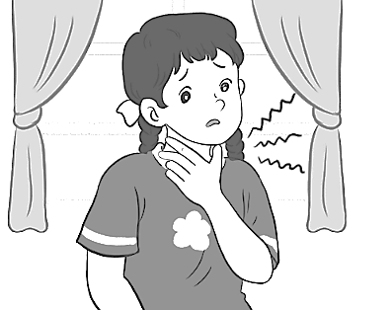
4. Let’s go to the ____________ to take some photos. | 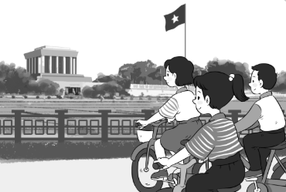
5. The main characters are the ________________ and the hare. | 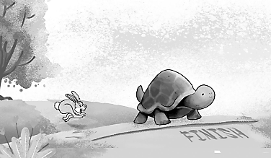

Task 7. Reorder the words to make sentences.

1. go to / last week?/ you / Did / Ha Long Bay // did / No,/ we / not./

..................................................................................................................................................................................................................................................................
2. parents / My / healthy food / do yoga // eat / and / daily./

.................................................................................................................................

3. sing? / How / did / cow / the /

.................................................................................................................................

4. The hare / but / the tortoise, / he did not win. / raced /

..................................................................................................................................................................................................................................................................

5. Opera House? / Do / visit / you want / to // do. / Yes, / I/
................................................................................................................................................................................................................................................................
ĐÁP ÁN BÀI KIỂM TRA ĐỊNH KỲ CUỐI KỲ II
MÔN: TIẾNG ANH - LỚP: 5

Task 1: Listen and number. (1 điểm – 0,2 điểm / 1 câu đúng)
1.D 2.E 3.B 4.A 5. C
Task 2: Listen and circle A, B or C. (1 điểm – 0,2 điểm / 1 câu đúng) 1.B 2. B 3. C 4.A 5.B
Task 3: Read and choose the correct answer. (2 điểm – 0,2 điểm / 1 câu đúng)
1. B 2. D 3. A 4. B 5. B
6. C 7. D 8. A 9. C 10. D
Task 4: Read and tick True or False. (1 điểm – 0,2 điểm / 1 câu đúng)
1: T 2: T 3: F 4: F 5: T
Task 5: Read the text again carefully then circle the correct answers. (1 điểm – 0,2 điểm / 1 câu đúng)
1: A 2: B 3: C 4: A 5: D
Task 6: Fill in the each blank with ONE suitable word. (1 điểm – 0,2 điểm / 1 câu đúng)
- do 2. exercise 3. sore throat 4. square 5. tortoise
Task 7: Reorder the words to make correct sentence. (1 điểm – 0,2 điểm / 1 câu đúng)
1. Did you go to visit Ha Long Bay last week? No, we did not.
2. My parents do yoga and eat healthy food daily.

3. How did the crow sing?

4. The hare raced the tortoise, but he did not win.

5. Do you want to visit Opera House? Yes, I do.

Nội dung bài thi này tổng là 8 điểm + 2 điểm nói = 10 điểm. (GV chủ động kiểm tra nói cho học sinh và cho điểm vào danh sách nói trước.)

