ĐỀ 12 | ĐỀ KIỂM TRA CUỐI HỌC KỲ II  NĂM HỌC 2025-2026  MÔN: TIẾNG ANH LỚP 5
PART I: LISTENING
Task 1: Listen and number

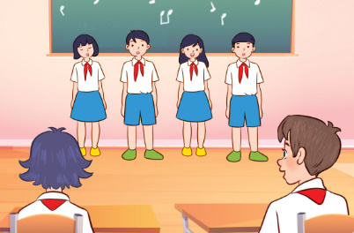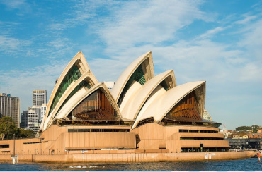
A. B.

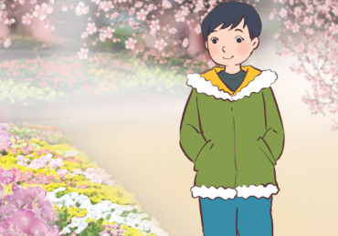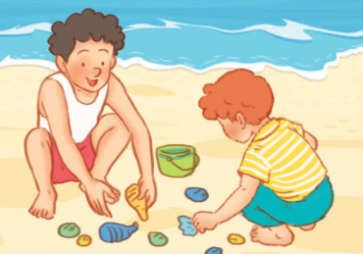

C. D.

E.

Task 2: Listen and circle the correct answer.

1. Where will you go at Tet? - We'll visit my grandparents in ____________.
A. the village B. the city C. the countryside
2. You look tired. What's the matter? - I have a _________. It hurts
- You should go to the dentist.
A. headache B. toothache C. stomach ache
3. I want to go out in the morning. Where do you want to go?
- I want to go ____________
A. Ngo Mon Square B. Museum of History C. Dam Sen Aquarium
4. How's the weather in New York, John? - It's _________ in summer.
How about the weather in Ha Noi? - It's very ___________ in winter.
A. hot/ warm B. warm/ cold C. cold/ warm
5. What do you think of Hoi An Old Town? - I think it's ____________
A. exciting B. peaceful C. beautiful
PART II: READING
Task 3: Read and circle the correct answer.
1. Odd one out: (Tìm từ khác loại)
A. season B. summer C. autumn D. spring
2. Odd one out:
A. fanstastic B. peaceful C. countriside D. beautiful
3. What’s ………….? – I have ……headache.
A. matter / a B. the matter /a C. is the matter/an D. the matter/ an
4 ……….. the weather in Hue in summer? – It’s sunny.
A. How B. What C. What’s D. How’s
5. Where do you want to visit? – I want …….... Dragon Bridge.
A. visit B. visited C. to visit D. visits
6……….will you go at Tet? - I’ ll go to a flower festival.
A. What | B. When | C. Where | D. Which
7. What will you……..on Teachers’ Day? - We’ll sing and dance.
A. do | B. did | C. does | C.have
8. What ………will you have at the party? - We will have milk tea.
A. food | B. drinks | C. fruits | D. vegetables
9. How does your sister ………healthy? – She …………. yoga regularly.
A. stays/ does | B. stay/ does | C. stay/ do | D. stays/ do
10. ………….does your brother play football? - He plays football twice a week.
A. How much | B. How many | C. How often | D. How long
Task 4: Read and tick True or False.
Hi, I’m Peter. Last year, I had a toothache. I was awful! One of my teeth
hurt for three days. I tried drinking warm water, but it didn’t help. My dad
gave me some medicine, but it didn’t stop the pain. In the end, I went to the
dentist. He stopped the toothache. I felt so much better! Today, I have a
headache. I took a rest, but I still have the headache. My mum told me to
drink more water, but it didn’t help. Later, I’ll take some medicine. I hope
that makes me feel better!
 | True | False
1. Peter had a toothache last year.
2. Peter’s mother gave him some medicine, but it didn’t stop the pain.
3. Peter didn’t go to the dentist.
4. Peter has a headache today.
5. His mum told him to drink more water, but it didn’t help.
Task 5: Read the text in Task 4 again and circle the correct answers.
1. When did Peter have a toothache? ____________
A. yesterday B. last week C. last year D. today
2. One of his teeth hurt for __________ days.
A. once B. two C. three D. four
3. ____________ gave him some medicine.
A. His mother B. His father C. His brother D.His sister
4. What’s the matter with Peter today? He has a _________________
A. headache B. stomach ache C. sore throat D. toothache
5. Did his father tell him to drink more water?
– ___________.
A. Yes, he does B. No, he doesn't C. Yes, he did D. No, he didn’t
PART II. WRITING
Task 6: Reorder the words to make correct sentences.
1. usually / do you / wear / What / in summer/ ?
……………………………………………………………………………………
2. walked / I / beach / the / on / family / my / with /.
……………………………………………………………………………………
3. I / visit / want to/ Hoan Kiem / Lake /.
……………………………………………………………………………………
4. think/ Ho Chi Minh City/is /big and exciting/Do you/?
……………………………………………………………………………………
5. 1 kilometre/ to my school / from/ It is about/ my house/.
……………………………………………………………………………………
Task 7: Fill the gaps with suitable words or phrases to complete the paragraph below.
This summer, I (1)__________ going to visit Phu Quoc for a holiday. It is about three hundred and ninety kilometres (2)___________ Ho Chi Minh City. I am going to get to the island (3)____________ car and ferry. I am going to stay in a big hotel in the centre of Phu Quoc. I’m going to visit Vinpearl Safari Park. It is an interesting zoo, and I’m going to (4)___________ lots of photos there. I’m going to take a cable car to Hon Thom Island. I’m going to go shopping at the night market (5)___________ buy some souvenirs. Tom thinks Phu Quoc is a fantastic place for a summer holiday.
THE END!

ĐÁP ÁN BÀI KIỂM TRA ĐỊNH KỲ CUỐI KỲ II
MÔN: TIẾNG ANH - LỚP: 5
Task 1: Listen and number. ( 1 điểm – 0,2 điểm / 1 câu đúng )
1. E 2. C 3. D 4. B 5. A
Task 2: Listen and circle A, B or C. ( 1 điểm – 0,2 điểm / 1 câu đúng )
1. C 2. B 3. A 4. B 5.A
Task 3: Read and choose the correct answer. ( 2 điểm – 0,2 điểm / 1 câu đúng )
1. A 2. C 3. B 4. D 5. C
6. C 7. A 8. B 9. B 10. C
Task 4: Read and tick True or False. ( 1 điểm – 0,2điểm / 1 câu đúng )
1. T 2. F 3. F 4. T 5. T
Task 5: Read the text again carefully then circle the correct answers. ( 1 điểm – 0,2 điểm / 1 câu đúng )
1. C 2. C 3. B 4. A 5. D
Task 6: Reorder the words to make correct sentence. ( 1 điểm) ( Mỗi câu đúng được 0,2 điểm)
1. usually / do you / wear / What / in summer/ ?
What do you usually wear in summer?
2. walked / I / beach / the / on / family / my / with /.
I walked on the beach with my family.
3. I / visit / want to/ Hoan Kiem / Lake /.
I want to visit Hoan Kiem Lake.
4. think/ Ho Chi Minh City/is /big and exciting/Do you/?
Do you think Ho Chi Minh City is big and exciting?
5. 1 kilometre/ to my school / from/ It is about/ my house/.
It is about 1 kilometre from my house to my school.
Task 7: Fill the gaps with suitable words or phrases to complete the paragraph below. ( 1 điểm)
- am 2. from 3. by 4. take 5. and

TAPESCRIPTS:
I/ TASK 1: LISTEN AND NUMBER
1. A: What food will we have at the party?
B. We'll have hamburgers, chips and apples. And what drink will you have?
A: We’ll have milk tea.
2. A: Tet is coming. Where will you go?
B: I'll go to a flower festival in the city centre.
3. A: Did you collect seashells on Nha Trang beach last Sunday?
B: Yes, I did. I collected it with my brother.
4. A: Do you think Sydney Opera House is peaceful?
B: Yes, I do. I think it's peaceful.
5. A: What will you do on Teachers' Day?
B: We’ll sing.
II/ TASK 2: LISTEN AND CIRCLE
1. A: Where will you go at Tet?
B: We'll visit my grandparents in the countryside.
2. A: You look tired. What's the matter?
B: I have a headache. It hurts
A: You should go to the dentist.
3. A: I want to go out in the morning. Where do you want to go?
B: I want to go Ngo Mon Square.
4. A: How's the weather in New York, John?
B: It's warm in summer. How about the weather in Ha Noi?
A: It's very cold in winter.
5. A: What do you think of Hoi An Old Town?
B: I think it's exciting.

MA TRẬN ĐỀ KIỂM TRA ĐÁNH GIÁ CUỐI HỌC KỲ II
MÔN THI: TIẾNG ANH 5
Thời gian làm bài thi: 40 phút.

STT | Phần | Nội dung cụ thể | Tỷ lệ kiến thức (%) |  |  | Tổng số câu
STT | Phần | Nội dung cụ thể | Nhận biết  (Mức 1) | Thông hiểu  (Mức 2) | Vận dụng  (Mức 3) | Tổng số câu
1. | NGHE | Bài 1: Nghe và đánh số thứ tự các bức tranh | 5 |  |  | 5 = 1đ (0,2/c)
2. | NGHE | Bài 2: Nghe và chọn đáp án đúng | 3 | 1 | 1 | 5 = 1 đ(0,2/c)
3 | NGỮ ÂM | Bài 3: Trọng âm (1 câu)  Từ khác loại (1 câu) |  | 1 | 1 | 2 = 0.4 đ(0,2/c)
3 | NGỮ PHÁP –  TỪ VỰNG | Chọn từ, cụm từ điền vào chỗ trống trong các câu riêng lẻ (8 câu) | 4 | 2 | 2 | 8 = 1,6 đ(0,2/c)
4 | ĐỌC HIỂU | Bài 4: Đọc đoạn văn tối đa 35-45 từ và xác định True/False | 2 | 2 | 1 | 5 = 1 đ (0,2/c)
5 | ĐỌC HIỂU | Bài 5: Đọc bài văn tối đa 35-45 từ và chọn đáp án đúng để điền vào chỗ trống | 2 | 2 | 1 | 5 = 1 đ(0,2/c)
6 | VIẾT | Bài 6: Sắp xếp từ thành câu hoàn chỉnh | 2 | 2 | 1 | 5 = 1 đ(0,2/c)
7 | VIẾT | Bài 7: Đọc đoạn văn và điền từ thích hợp vào chỗ trống | 2 | 2 | 1 | 5 = 1 đ(0,2/c)
 | Tỷ lệ |  | 20 câu | 12 câu | 8 câu | 40 = 8đ
8 | NÓI | 4 câu hỏi | 3 | 1 |  | 4 = 2 đ (0,2/c)

